Name : Muhammad Sohail
Reg:FA24-BSE-105
Sub: WEB TECHNOLOGY

Lab#4

Graded Task 1 code & out put:
<!DOCTYPE html>
<html lang="en">
<head>
<meta charset="UTF-8">
<meta name="viewport" content="width=device-width, initial-scale=1.0">
<title>Graded_Task_1</title>

<style>
.main-section{
background-color: aquamarine;
}

.main-dev{
display: flex;
align-items: center;
justify-content: center;
flex-direction: column;
background-color: azure;
}

.body-div{
display: flex;
flex-direction: row;
justify-content: center;
align-items: center;
border: 2px solid black;
background-color: rgb(242, 237, 230);
}

.conctact{
display: flex;
flex-direction: column;
align-items: center;
justify-content: center;
border: 2px solid rgb(238, 122, 122);

}
</style>
</head>
<body>
<section class="main-section">
<div class="main-dev">
<img src="#" alt="Sohail_picture">
<h2>Muhammad Sohail</h2>
<p>I am currently Islamabad based and basicly I am from Waziristan!.</p>
<p>I a student of software engineering in Comsats University Islamabad, <br>
Currently I am in my fifth semester and i am fucll stack AI engineer. <br>
Currently perueing Agentic AI.</p>
</div>

<div class="body-div">
<div>
<h3>Projects</h3>
<ul>
<li><a href="#">Campus connect</a></li>
<li > <a href="#">USM(university sports managment)</a></li>
<li><a href="#">preghalfragrances</a></li>
</ul>
</div>

<div>
<h3>Skills</h3>
<ul>
<li>Frontend</li>
<li>Backend</li>
<li>Designer</li>

</ul>
</div>

</div>

<div class="conctact">
<h3>contact</h3>
<p>email: sohailwazir2004@gmail.com</p>
<p >Contact: 03098923343</p>
</div>
</section>
</body>
</html>

<!-- Create a professional personal profile card (photo, name, designation, short bio, at least three statistics, contact
info, primary action button) using external CSS, class selectors, the box model, box-sizing, border-radius, box
shadow, object-fit, and :hover/:active states. -->

Result:
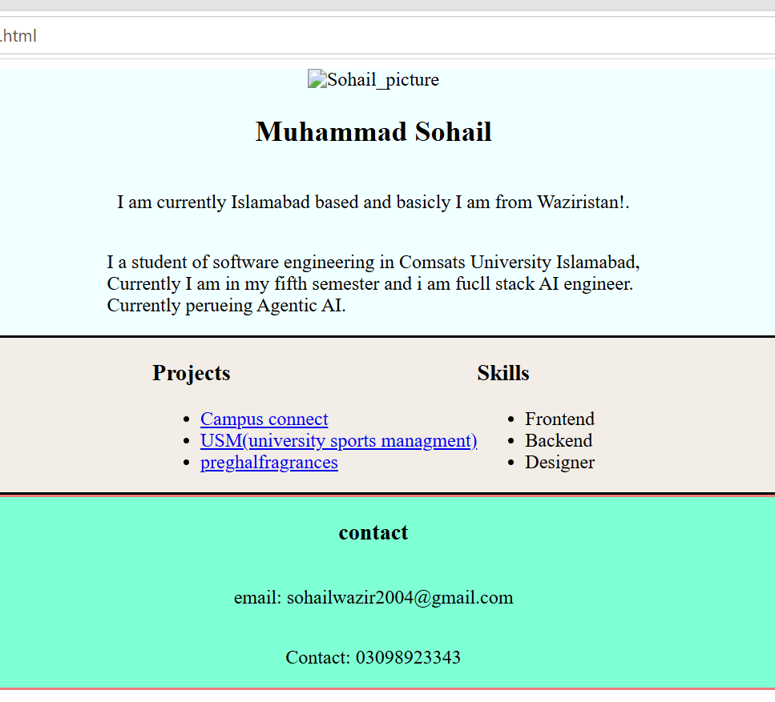

Graded Task#2:
Code:
<!DOCTYPE html>
<html>
<head>
<title>Article Preview</title>

<style>
body {
font-family: Arial;
background-color: lightgray;
}

.article {
background-color: white;
width: 500px;
padding: 20px;
margin: 50px auto;
border-radius: 10px;
box-shadow: 0 0 10px gray;
}

.category {
color: blue;
font-size: 14px;
font-weight: bold;
}

h1 {
font-size: 28px;
font-weight: bold;
}

.author {
font-size: 14px;
color: gray;
}

.description {
font-size: 16px;
line-height: 1.5;
}

.read-more {
color: blue;
font-weight: bold;
text-decoration: none;
}

.read-more:hover {
color: red;
text-decoration: underline;
}

.read-more:active {
color: green;
}
</style>
</head>

<body>

<div class="article">

<p class="category">Technology</p>

<h1>What is Artificial Intelligence?</h1>

<p class="author">By Muhammad Sohail - October 5, 2026</p>

<p class="description">
Artificial Intelligence is a technology that allows
computers to perform tasks that normally need human thinking.
</p>

<a href="#" class="read-more">Read More</a>

</div>

</body>
</html>

Result:
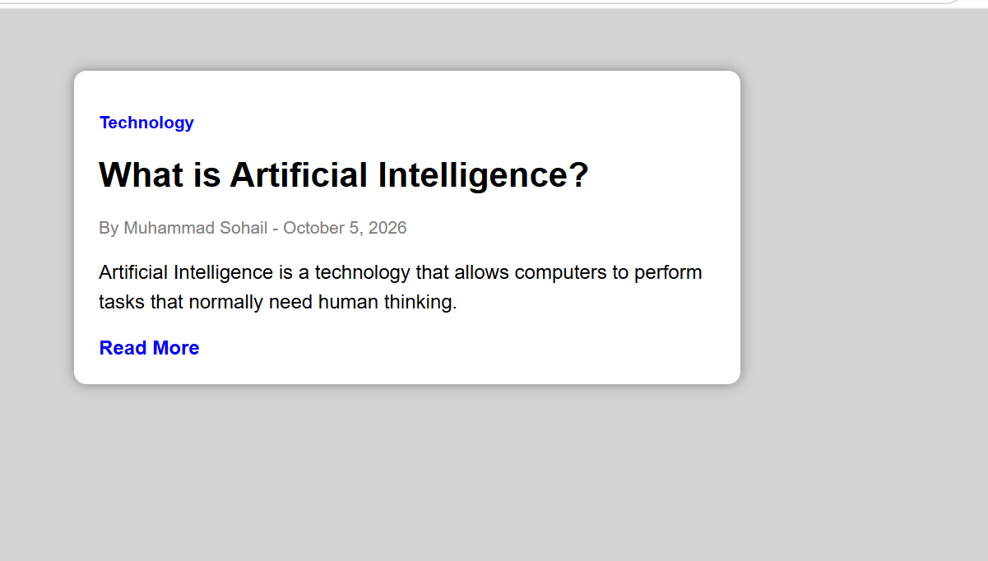

Grade Task#3:
Code:
<!DOCTYPE html>
<html>
<head>
<title>Product Card</title>

<style>
* {
box-sizing: border-box;
}

body {
background-color: lightgray;
font-family: Arial;
}

.product-card {
width: 350px;
margin: 50px auto;
background-color: white;
border-radius: 10px;
box-shadow: 0 0 10px gray;
overflow: hidden;
}

.image-box {
position: relative;
}

.image-box img {
width: 100%;
height: 220px;
object-fit: cover;
}

.sale-badge {
position: absolute;
top: 10px;
left: 10px;
background-color: red;
color: white;
padding: 5px 10px;
border-radius: 5px;
}

.product-info {
padding: 20px;
}

.category {
color: gray;
font-size: 14px;
}

h1 {
font-size: 24px;
}

.description {
line-height: 1.5;
}

.price {
font-size: 22px;
font-weight: bold;
}

.price span {
font-size: 16px;
color: gray;
text-decoration: line-through;
}

.stock {
color: green;
font-weight: bold;
}

button {
padding: 10px;
border: none;
border-radius: 5px;
cursor: pointer;
transition: 0.3s;
}

.cart-button {
background-color: black;
color: white;
}

.wishlist-button {
background-color: lightgray;
color: black;
}

button:hover {
transform: scale(1.05);
}

button:active {
transform: scale(0.95);
}
</style>
</head>

<body>

<div class="product-card">

<div class="image-box">

<img src="https://via.placeholder.com/500x300"
alt="Product Image">

<span class="sale-badge">SALE</span>

</div>

<div class="product-info">

<p class="category">Shoes</p>

<h1>Running Shoes</h1>

<p class="description">
Comfortable shoes for running and everyday use.
</p>

<p class="price">
$40
<span>$60</span>
</p>

<p class="stock">In Stock</p>

<button class="cart-button">Add to Cart</button>

<button class="wishlist-button">♡ Wishlist</button>

</div>

</div>

</body>
</html>

Result:
